
MINI-PROJECT 2
Virtual Memory
Prepared by
Group: มูลนิธิทนายตั้ม ช่วยสู้
Guntee Doungmanee | 67070501003
Drarun Yookphan | 67070501016
Natthawat Primsirikunawut | 67070501027
Rattathamnoon Buranapattana | 67070501037
Wisit Suwannao | 67070501042
Supawit Marayat | 67070501045
Polwarit Watthanahemmarat | 67070501067
Submitted to
Asst. Prof. Rajchawit Sarochawikasit
This report is part of CPE333 Operating Systems
Department of Computer Engineering, Faculty of Engineering
King Mongkut’s University of Technology Thonburi
Semester 1, Academic Year 2026

Contents
Problem 1: Project scope and design 3
Step 1: Virtual memory and page faults 4
Step 2: How the tool works 5
Problem 2: Experimental method and results 8
Step 1: Test environment and method 8
Step 2: Results 11
Step 3: Post-merge checks 15
Problem 3: Limitations and conclusion 17
Step 1: Limitations 17
Step 2: Conclusion 18
References 19
Appendix: Reproduction steps and evidence 20
Step 1: Check out the tested source 20
Step 2: Create and prepare the Lima VM 20
Step 3: Build and load the module 20
Step 4: Inspect a live process 20
Step 5: Run the demo and regression checks 20
Step 6: Run experiments E1 to E8 21
Step 7: Unload and remove build artifacts 21

Problem 1: Project scope and design
The project is a Linux tool for inspecting a process's memory regions, virtual address space, and minor and major page faults. It combines the pfcount kernel module, the pfstat command-line program, and the faultgen workload generator. We tested the merged PR #11 source on Ubuntu 24.04.5 with Linux 6.8.0-142-generic on ARM64. The build, demo, regression suite, and experiments E1 to E8 all completed in that environment.
These measurements describe different things. A process can reserve a large virtual range before its pages become resident, and file cache, readahead, fault-around, and Transparent Huge Pages (THP) can all change the recorded fault counts. The results describe the tested kernel configuration; they do not establish compatibility with other kernels or measure probe overhead.
Table 1: Project requirements and how we checked them
Requirement | Implementation | Check
Select a process | pfstat PID writes the target PID to /proc/pfcount/target | Confirm the reported PID and process name
Count memory regions | Walk the process’s VMAs | Compare with /proc/PID/maps
Measure virtual address space | Sum vm_end - vm_start for every VMA | Compare with maps, mm->total_vm, and VmSize
Count minor and major faults | Read lifetime counters and count live faults with a kretprobe | Compare with kernel counters using the same process scope
Explain virtual memory behavior | Relate VMAs, demand paging, cache, and THP to E1 to E8 | Analyze the measured results in Problem 2, Step 2
The required output is the four process-level measurements listed above. Watch mode, run mode, descendant tracking, RSS reporting, and exit-time snapshots are additional features. We tested the tool in one Linux VM with one kernel configuration, described in Problem 2, Step 1.

Step 1: Virtual memory and page faults

Virtual address space and VMAs
A process uses a virtual address space that Linux describes through struct mm_struct. The kernel divides it into Virtual Memory Areas (VMAs). Each VMA is a contiguous address range with common permissions and backing information. Its start and end addresses are vm_start and vm_end, so its size is their difference [3].
A VMA may contain many pages. The number of VMAs therefore is not the number of pages or the amount of resident memory. Summing the VMA sizes gives the mapped virtual address space. Comparing this value with RSS shows how much address space is mapped and how much memory is resident. Experiment E7 uses both measurements to illustrate demand paging.

Page faults and fault classification
With demand paging, Linux prepares a page when a process first accesses it. A minor fault can be handled without storage I/O. A major fault requires I/O to obtain the page [4]. These counters record kernel fault events. They do not count load/store instructions or device I/O requests.
The module reads the return value from handle_mm_fault() and applies the classification rules used by mm_account_fault() in the tested kernel. A VM_FAULT_RETRY result is not counted until the final attempt completes. A VM_FAULT_ERROR result is recorded as a failed fault. A successful result is major when VM_FAULT_MAJOR is set or the original flags contain FAULT_FLAG_TRIED; otherwise, it is minor [2, 5].
if (ret & VM_FAULT_RETRY)
/* wait for the final attempt */;
else if (ret & VM_FAULT_ERROR)
/* record a failed fault */;
else if ((ret & VM_FAULT_MAJOR) || (flags & FAULT_FLAG_TRIED))
/* count a major fault */;
else
/* count a minor fault */;
The assignment suggests the exceptions:page_fault_user tracepoint. That tracepoint belongs to the x86 page-fault path, while our test VM is ARM64. It also fires before the kernel has finished handling the fault, so it does not directly provide the information needed to distinguish minor from major faults [2, 5]. We instead use a kretprobe on handle_mm_fault() and classify the completed result. This choice matches the Linux 6.8 accounting rules used in the test environment. We did not measure the probe’s performance overhead systematically.

Page cache, readahead, and huge pages
A file-backed mapping can use the page cache without a new device read. We separated cold-cache and warm-cache cases and used MADV_RANDOM in selected tests to reduce readahead. On the tested kernel, disabling readahead did not disable fault-around. Linux could still map nearby pages that were already in the cache.
Transparent Huge Pages (THP) can also change fault counts. The faultgen program requests THP with MADV_HUGEPAGE and ordinary pages with MADV_NOHUGEPAGE. These calls advise the kernel but do not guarantee that every mapping receives a huge page [6]. The fault counts therefore describe the workload; on their own, they do not prove that every requested mapping used THP.

Step 2: How the tool works
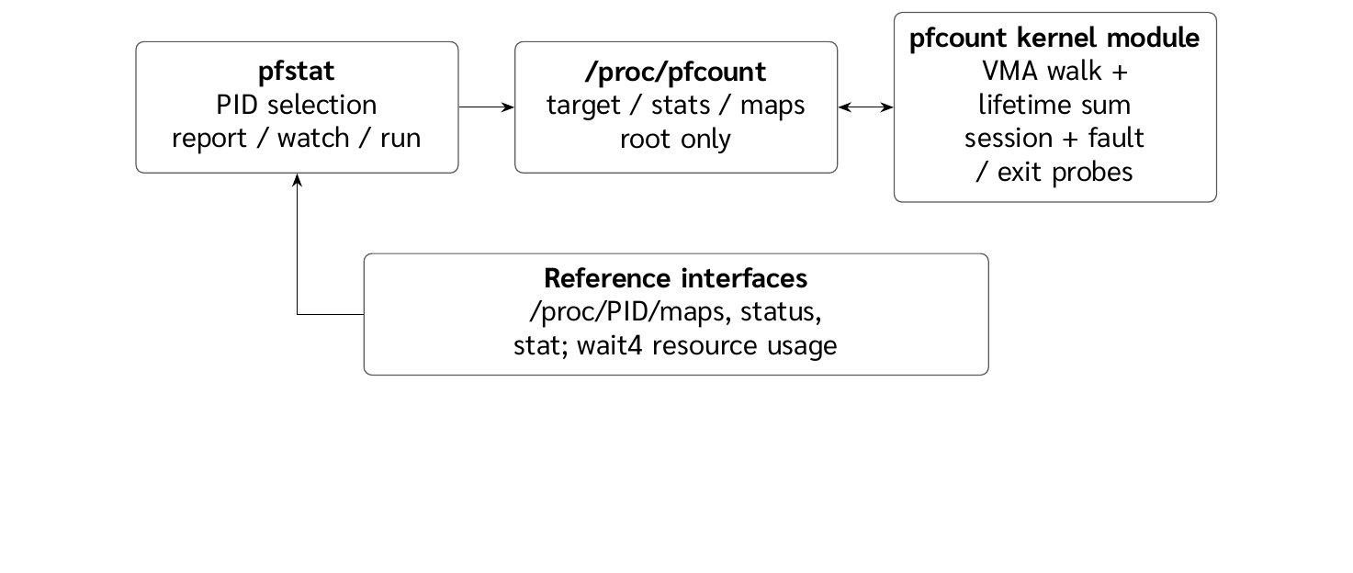
Figure 1: User-space tools, kernel data sources, and comparison interfaces

Counting regions and virtual address space
When a user selects a PID, pfstat writes it to /proc/pfcount/target and reads the module’s stats and maps interfaces. The module obtains a reference to the process address space with get_task_mm(), takes mmap_read_lock_killable(), and walks the VMAs with VMA_ITERATOR and for_each_vma. It then releases the lock and the address-space reference with mmput() [2, 3].
For each VMA, the module increments the region count and adds vm_end - vm_start to the virtual size. It also groups mappings as file-backed, anonymous, heap, stack, or special mappings. Those groups help explain the output; they do not change the definition of a region. The module’s total is checked against the address ranges in /proc/PID/maps, mm->total_vm, and VmSize.
mm = get_task_mm(task);
mmap_read_lock_killable(mm);
VMA_ITERATOR(vmi, mm, 0);
for_each_vma(vmi, vma) {
regions++;
vsize += vma->vm_end - vma->vm_start;
}
mmap_read_unlock(mm);
mmput(mm);
This snippet shows the main sequence. The implementation also handles a missing task, a task without an address space, and an interrupted lock acquisition.

Lifetime and live fault counters
Lifetime counters combine min_flt and maj_flt values from live threads with totals transferred to signal_struct when threads exit. The reviewed source uses sig->stats_lock and a sequence/retry pattern like /proc/PID/stat. This avoids counting a thread twice or reading it while its totals are being transferred [2, 7]. These counters cover the thread group from process start.
Live counters start when the user selects a target. On entry to the handle_mm_fault() kretprobe, the module checks whether the faulting process is in scope and saves the flags and backing type for that invocation. On return, it uses the completed result to update minor, major, anonymous, file-backed, or error counters. Keeping entry data with its invocation prevents the module from classifying a fault from a CPU error code before the kernel has handled it [2, 5, 8].

Target sessions and process identity
Each target selection creates a new pf_session with a PID reference, start time, and its own counters. The probe entry handler holds a reference to the session that accepted a fault until the return handler finishes. A fault that began under an earlier target therefore cannot increment the new target’s counters. RCU publication and reference counting let an in-flight handler finish safely while the target changes.
The module compares the thread-group struct pid, not only the numeric TGID. The kernel may reuse a PID after reaping the original process. Holding a reference to the PID object keeps the module from treating a new process with the same number as the original target. Problem 2, Step 3 checks this behavior with the PID-reuse regression.

Exit snapshots and permissions
For a short-lived process that exits before the user reads its stats, the module captures the region count, virtual size, and peak size through a kprobe on acct_collect(exitcode, group_dead). The kernel calls this function after atomic_dec_and_test() identifies the last thread and before exit_mm(), while the address-space counters are still available. The probe uses group_dead rather than guessing that a thread is last from signal->live == 1 at the start of do_exit() [2, 9].
The module sets permissions to 0600 for /proc/pfcount/target and 0400 for stats and maps. The interface can inspect the address space of a PID that the caller could not otherwise read, so the files are restricted to root. Our tests invoked the tool with sudo.

Command-line modes
Table 2: Main pfstat modes
Command | Behavior
sudo tools/pfstat PID | Print one summary and compare it with procfs
sudo tools/pfstat PID --maps | Include the process’s VMA list
sudo tools/pfstat PID -w 0.5 | Sample repeatedly and calculate rates using elapsed time
sudo tools/pfstat -- CMD | Run a command and count faults from before exec until exit
sudo tools/pfstat -f -- CMD | Include descendants that remain within the tracked ancestry
In run mode, the parent stops the child with SIGSTOP, selects it as the target, reads the lifetime baseline, and then allows it to exec the requested command. The program subtracts that baseline before comparing its live counters with wait4(). The child drops back to the invoking user’s privileges before exec. After fork, the program restores the inherited SIGCHLD disposition in the child and uses a cleanup path to reset the target and follow state if execution or waiting fails. The post-merge test also covers a parent that inherited SIGCHLD=SIG_IGN.
The terminal report below is a separate example for the current shell. It shows the VMA total, virtual size, fault counters, and mapping groups in one view; the E1 measurements that follow use the recorded sleep and PID 1 runs.
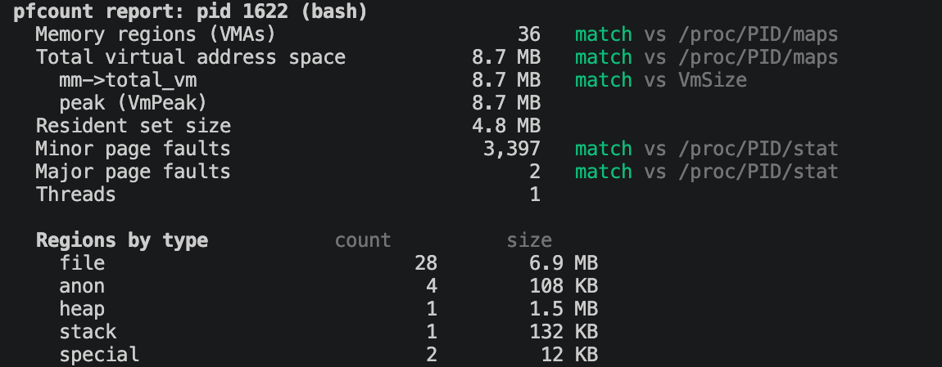
Figure 2: Example pfstat report for the shell, including procfs comparisons and VMA groups.
In this shell example, the report finds 36 VMAs and 8.7 MB of virtual space. Both values match the mapping ranges in the process’s maps file. mm->total_vm matches VmSize, and 3,397 minor and 2 major faults match the corresponding stat counters. The final rows group the VMAs by backing type.

Problem 2: Experimental method and results

Step 1: Test environment and method
Table 3: Post-merge test environment
Item | Value
Host and virtual machine | macOS host; Lima VM with 4 reported vCPUs and 3,905 MB guest memory
Guest and kernel | Ubuntu 24.04.5 LTS; Linux 6.8.0-142-generic; aarch64
Compiler | GCC 13.3.0
Page size and THP | 4,096 bytes; THP mode set to madvise
Fault-around and readahead | 65,536 bytes and 128 KiB, respectively
Kernel options | CONFIG_KPROBES=y, CONFIG_KRETPROBES=y, CONFIG_BSD_PROCESS_ACCT=y
Source revision | PR #11 merge commit 5fbcb767
The saved environment record identifies the guest kernel, required kernel options, and exact merge commit used for the post-merge measurements. The capture below isolates the three required kernel options so they remain readable at print size; the kernel version and architecture are recorded in the terminal output above.
commit: 5fbcb7679298f36e2bae8b7cd3dbe6bf6a609800
Linux lima-cpe333 6.8.0-142-generic #142-Ubuntu SMP PREEMPT_DYNAMIC Wed Sep 2 14:30:29 UTC 2026 aarch64 aarch64 aarch64 GNU/Linux
CONFIG_BSD_PROCESS_ACCT=y
CONFIG_KPROBES=y
CONFIG_KRETPROBES=y
Figure 3: Terminal output confirming the kernel options required by the module.
We kept raw outputs and environment details in the evidence/ directory so the post-merge measurements remain separate from earlier PR tests. The program labels sizes as MB and KB but uses a base of 1,024. This report uses MiB and KiB when stating exact sizes; for example, anon:64 means 64 MiB.

Build and load
Inside Ubuntu, vm.sh prepared the Lima VM and installed build tools and headers matching uname -r. The build and load command, make clean && make all && make load, completed and created /proc/pfcount/maps, /proc/pfcount/stats, and /proc/pfcount/target.
Kbuild compiled and linked the module, and the module loaded. The saved log shows a BTF step but does not establish whether BTF data was generated. Other kernels and architectures were not tested.
./vm.sh setup
./vm.sh make clean
./vm.sh make all
./vm.sh make load
./vm.sh make demo
./vm.sh make experiments
./vm.sh run sudo sh tests/regress.sh
./vm.sh make unload
./vm.sh make clean
The saved build/load log records the object compilation, module link, and proc entries. Workspace-specific path prefixes are omitted here.
make -C module
CC [M] pfcount.o
MODPOST Module.symvers
LD [M] pfcount.ko
BTF [M] pfcount.ko
Test binaries compiled: faultgen, threadexit, threadchurn, uffdblock
/proc/pfcount/: maps, stats, target

Figure 4: Terminal output confirming that the loaded module exposes its proc interfaces.

End-to-end demo
The demo ran sudo tools/pfstat -w 0.5 -- tests/faultgen with the phases sleep:1 anon:64 sleep:1 file:/tmp/pfcount-big.bin sleep:1 free sleep:1. The Terminal capture below and the full transcript in evidence/post-merge-5fbcb76/02-demo-terminal-capture.txt show the same run (PID 2508, exit 0). The faultgen checkpoints are cumulative from process start, while pfstat subtracts the baseline recorded before exec; this run excludes 468 earlier minor faults. The resulting 16,521 minor and 8,193 major faults match the baseline-adjusted getrusage() comparison.
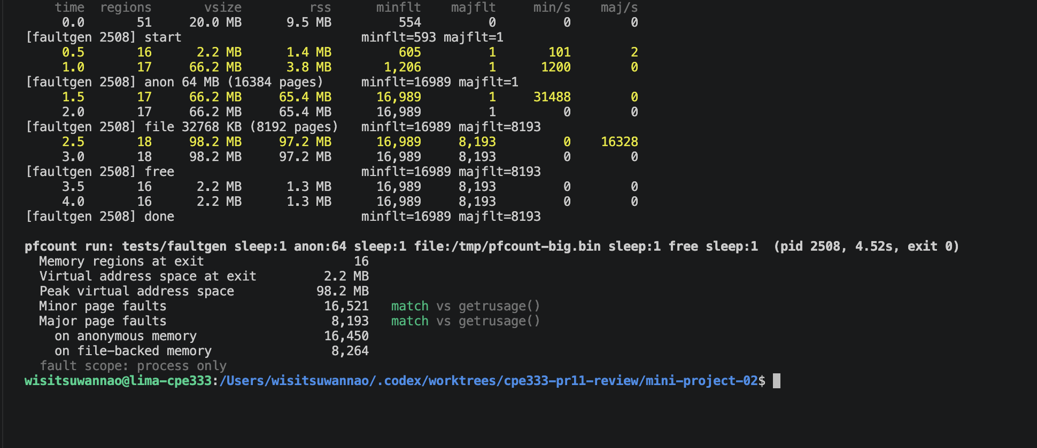
Figure 5: Actual Terminal output from the demo run, including the interval samples and matching exit-time fault totals.

How we checked the results
We compared region counts and address-space sizes using a process that remained stable while the module and procfs were read. In run mode, we compared the final live counters with the child usage returned after exit, after subtracting the lifetime baseline. Agreement between these interfaces supports the observed behavior in the tested cases; both still rely on counters maintained by the same Linux kernel.
E1 compared the report with procfs. E2 to E6 varied anonymous mappings, file cache, readahead, and THP. E7 recorded virtual size and RSS over time and then unmapped the regions. E8 compared ordinary programs with and without descendant tracking. The post-merge regression suite covered retargeting, PID reuse, simultaneous thread exit, lifetime counter reads, module unload during a blocked fault, and cleanup after inherited SIGCHLD settings. The post-merge suite did not test access by a non-root user, and the submitted evidence does not include that case.
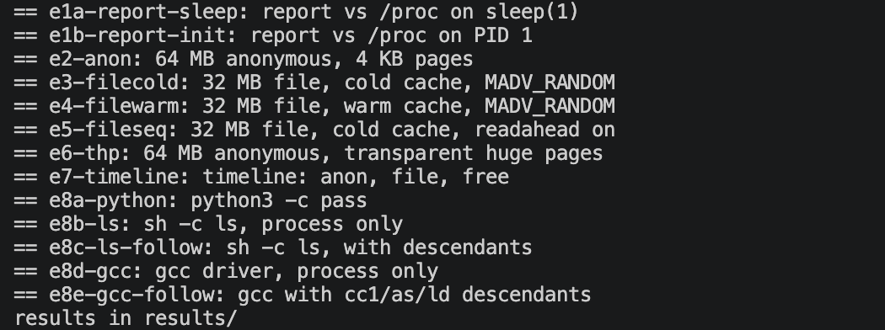
Figure 6: Terminal summary of the E1 to E8 cases run by the experiment script. Numeric results appear in the following tables and discussion; the E7 values come from a separate run of the same command.

Step 2: Results

E1: comparison with procfs
Table 4: E1 results from merge commit 5fbcb767
Target | Regions | Virtual size | Minor faults | Major faults
sleep | 30 | 5.6 MB | 106 | 0
PID 1, systemd | 113 | 21.9 MB | 12,986 | 94
The saved E1 logs also contain the mapping breakdown. These condensed output records omit region addresses and keep the cross-checks and VMA groups together:
sleep (pid 10605): 30 VMAs, 5.6 MB; 106 minor, 0 major
maps, VmSize, and /proc/PID/stat comparisons: match
file 24/5.2 MB; anon 2/56 KB; heap 1/132 KB; stack 1/132 KB; special 2/12 KB
systemd (pid 1): 113 VMAs, 21.9 MB; peak 22.0 MB; RSS 12.1 MB
12,986 minor, 94 major; maps, VmSize, and /proc/PID/stat comparisons: match
file 98/18.5 MB; anon 11/356 KB; heap 1/2.9 MB; stack 1/132 KB; special 2/12 KB
For both targets, the region count and summed address ranges matched maps. The module’s mm->total_vm matched VmSize, and its lifetime fault counts matched stat in the recorded reads. PID 1 provided a system-process check under root. Its fault count changes with system activity, so these values describe the recorded run rather than a fixed property of PID 1.

E2 to E6: mapping type and memory settings
Table 5: E2 to E6 process-only counts compared with getrusage()
Test | Workload | Minor | Major | Comparison
E2 | Anonymous mapping, 64 MiB | 16,538 | 1 | Match
E3 | Cold file, 32 MiB, RANDOM | 143 | 8,193 | Match
E4 | Warm file, 32 MiB, RANDOM | 652 | 1 | Match
E5 | Cold file, 32 MiB, readahead | 655 | 2 | Match
E6 | Anonymous mapping, 64 MiB, THP request | 188 | 1 | Match
E2 wrote once to each ordinary page in a 64 MiB anonymous mapping. At a 4 KiB page size, the mapping contains 16,384 pages. The 16,538 minor faults also include process startup activity while monitoring was active, so the process-wide total is not expected to equal the number of intentional writes exactly.
E3 read a 32 MiB file, or 8,192 pages, after requesting that its data be dropped from the page cache. The program used MADV_RANDOM. It recorded 8,193 major faults, including one that occurred before the file read. The increase during the read is consistent with 8,192 pages; major faults do not directly count device I/O requests.
E4 read a file already in cache. It produced mostly minor faults, and far fewer file faults than the 8,192 pages in the file. This result is consistent with fault-around mapping multiple nearby cached pages per fault. The configured fault_around_bytes=65536 spans 16 ordinary pages. E5 enabled readahead for a cold file and recorded 2 major faults, compared with 8,193 in E3. Together, these runs show that fault counts depend on cache state, readahead, and fault-around, not only file size.
E6 requested THP for a 64 MiB anonymous mapping and recorded substantially fewer minor faults than E2. This is consistent with a fault mapping more memory at a time. If the kernel backs the whole region with 2 MiB huge pages, it would use about 32 such pages, but startup and other activity remain in the process-wide count. We did not collect AnonHugePages for every mapping, so the fault count alone does not confirm that all requested pages became huge pages.
The saved run summaries also show how the counts split between anonymous and file-backed memory. Each pair below matched the corresponding getrusage() result:
E2 anon:64 minflt=16,538 majflt=1 anon=16,462 file-backed=77
E3 filecold minflt=143 majflt=8,193 anon=71 file-backed=8,265
E4 filewarm minflt=652 majflt=1 anon=68 file-backed=585
E5 fileseq minflt=655 majflt=2 anon=72 file-backed=585
E6 thp:64 minflt=188 majflt=1 anon=112 file-backed=77
fault scope: process only

E7: virtual size and RSS over time
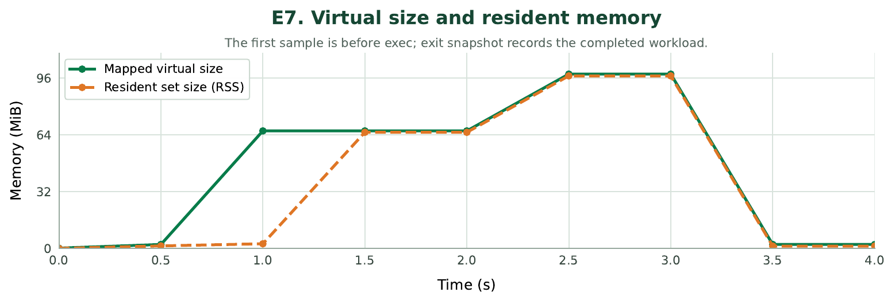
Figure 7: Virtual size and RSS recorded by the E7 command-line timeline
When the program created an anonymous mapping, virtual size grew from about 2.2 MiB to 66.2 MiB before RSS reached the same level. At 1.0 second, RSS was 2.6 MiB. After the program touched the pages, RSS rose to 65.4 MiB. Mapping and reading a 32 MiB file increased the totals to about 98.2 MiB virtual size and 97.2 MiB RSS. After munmap, both returned close to their earlier levels. This run shows that reserving a range does not immediately make all of its pages resident in RAM.
The first watch-mode sample can occur between fork and exec or while the address space is changing. A sampled maximum should therefore not be treated as the child program’s peak without checking the exit-time snapshot. The module reads the peak from the mm counters when the process exits. The reported minor/second and major/second rates use the counter difference divided by elapsed time between samples.
E7 comes from a separate run of the same command (PID 2286), not from the scripted batch that produced E1 to E6 and E8 (PIDs 10605 to 10663). The Terminal capture shows the full sample sequence and the matching exit-time totals used for this timeline. The searchable transcript is in evidence/post-merge-5fbcb76/experiment-results/e7-timeline.txt.
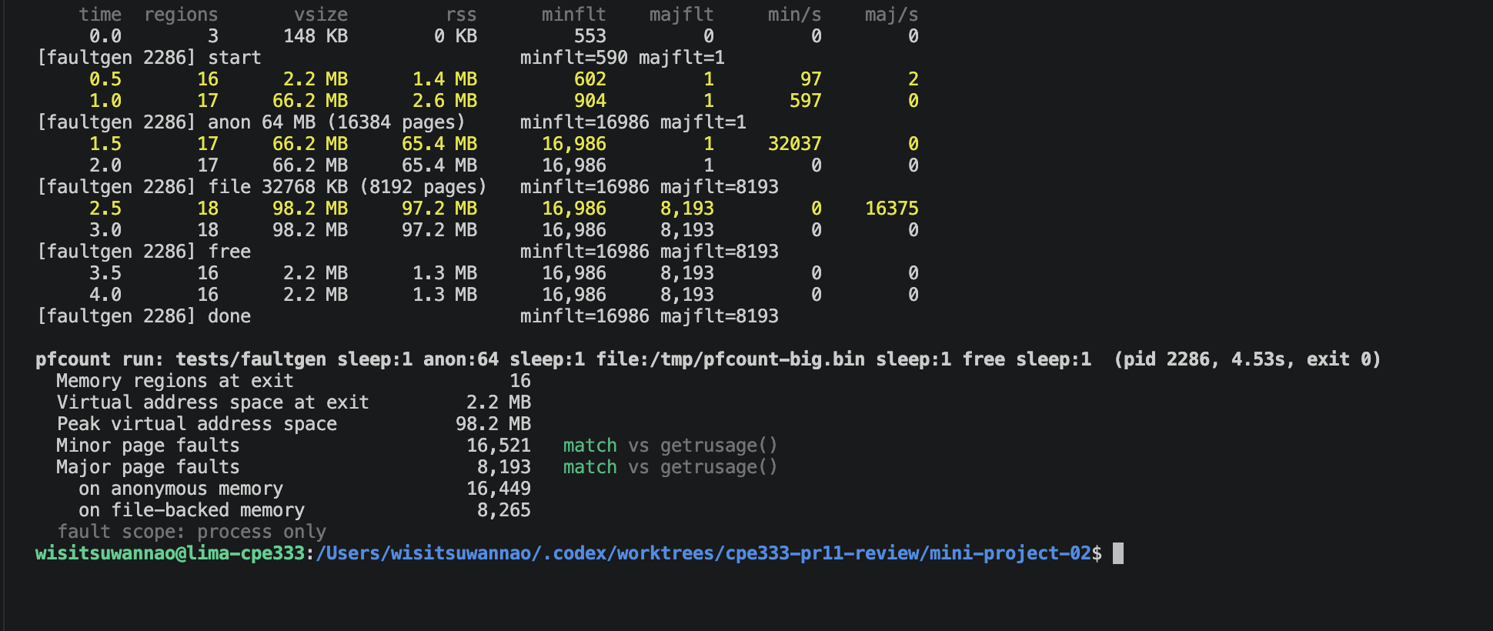
Figure 8: Terminal output from the E7 run (PID 2286), with live virtual-size and RSS samples and the exit summary.

E8: process scope and descendants
Table 6: E8 results under different fault scopes
Command | Minor | Major | Reference comparison
python3 -c pass | 1,234 | 0 | Matches getrusage()
sh + ls, without -f | 258 | 0 | 135 below getrusage()
sh + ls, with -f | 390 | 0 | Matches wait4()
gcc, without -f | 287 | 0 | 5,700 below getrusage()
gcc, with -f | 5,971 | 0 | Matches wait4()
The shell and GCC launch other processes. In process-only mode, pfstat counts the selected process but not its children. The reference returned by wait4() can include usage from waited children. In these runs, enabling follow mode brought the ls and GCC results into agreement with their waited-descendant references. Python did not create a child and matched getrusage() in process-only mode. The differences in the table reflect the scope used by each counter; they do not by themselves show a counting error.
wait4() does not always include every descendant. A child may be auto-reaped when its parent sets SIGCHLD to SIG_IGN. A child reparented before it is waited for may also be absent from the reference [4, 9]. The CLI therefore labels the reference as waited descendants only and explains when the live count exceeds it. The post-merge cleanup test covers the inherited SIGCHLD=SIG_IGN case.
The minor-fault lines from the saved E8 outputs show the scope difference for the same shell and compiler workloads. Only the column padding is shortened:
$ sudo tools/pfstat -- sh -c 'ls -R /usr/include >/dev/null'
Minor page faults 258 differs by -135 vs getrusage()
$ sudo tools/pfstat -f -- sh -c 'ls -R /usr/include >/dev/null'
Minor page faults 390 match vs wait4(), waited descendants only
$ sudo tools/pfstat -- gcc -O2 -o /tmp/fg tests/faultgen.c
Minor page faults 287 differs by -5700 vs getrusage()
$ sudo tools/pfstat -f -- gcc -O2 -o /tmp/fg tests/faultgen.c
Minor page faults 5,971 match vs wait4(), waited descendants only

Step 3: Post-merge checks
We reviewed and tested the source at merge commit 5fbcb767; the measurements below come from that revision, not from a pre-merge branch. The original review focused on target changes during faults, PID reuse, concurrent thread exit, lifetime-counter aggregation, and session cleanup during module unload.
Table 7: Build, demo, and workflow checks after merge
Case | Check | Observed result
Build and load | make clean && make all && make load | Passed; all proc entries were created
Demo | make demo; compare faults with getrusage() | Exit status 0; minor and major counts matched
Experiments | Run E1 to E8 with scripts/experiments.sh | Exit status 0; E8 scope differences were explained
Cleanup | Run make clean after testing | Passed; test binaries were removed

The regression screenshot and saved log show the same checks, with different reused PIDs: 2613 in the image and 2579 in the log.
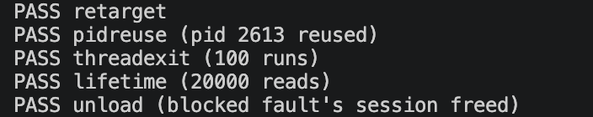
Figure 9: Terminal results from the post-merge lifecycle and concurrency regression suite.
Table 8: Lifecycle and concurrency regression checks after merge
Case | Check | Observed result
Retarget | Generate faults in A, then select stopped process B | Passed; A’s faults did not enter B’s session
PID reuse | Reuse the numeric PID of an earlier target | Passed; old target remained exited and its counters did not change
Concurrent thread exit | End a thread group concurrently | Exit snapshots were complete in 100 runs
Lifetime aggregation | Read counters while creating and exiting threads | 20,000 reads; no counter decrease observed
Unload during a blocked fault | Unload while userfaultfd held a fault | Passed; canceled-probe sessions were released during unload
Inherited SIGCHLD | Run pfstat -f -- /bin/true with parent SIGCHLD=SIG_IGN | Passed; child exited 0, target reset to idle, follow reset to N
The merged source retains a reference to the session that accepted each fault until the return handler completes. It identifies targets by struct pid, uses group_dead to detect the final thread, and protects lifetime totals with stats_lock. It also releases sessions left by canceled probes during module unload [2]. In run mode, the program temporarily sets SIGCHLD to the default disposition while waiting and restores the child’s inherited disposition before exec. The post-merge test confirmed that wait4() still collects the child status and that cleanup returns the target and follow state to idle and N.
The source sets 0600 on /proc/pfcount/target and 0400 on stats and maps. We did not test access by a non-root user after merge, so the submitted evidence does not include that case.
The inherited SIGCHLD cleanup check also captured the process summary and the final idle state of the module. The full transcript is in evidence/post-merge-5fbcb76/04-sigchld-cleanup.txt.
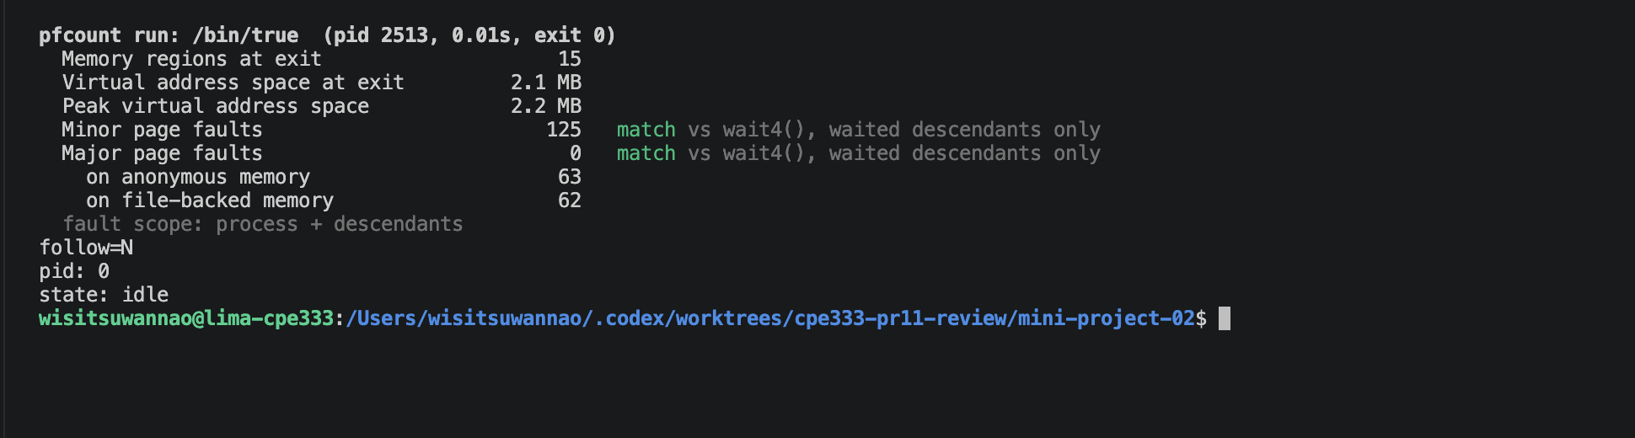
Figure 10: Terminal output for the inherited SIGCHLD ignore cleanup check (PID 2513), followed by the idle status.
GitHub Actions checks were not configured for the branch we reviewed. The build and regression results in this report came from manual runs inside Lima, not from an automated GitHub workflow [10].

Problem 3: Limitations and conclusion

Step 1: Limitations
The results apply to Ubuntu 24.04.5, Linux 6.8.0-142-generic, ARM64, and the kernel options in Table 3. Without CONFIG_BSD_PROCESS_ACCT=y, the module cannot register the acct_collect() probe and therefore cannot capture exit snapshots. It can still report a running target, but it cannot confirm final values for a short-lived process [2]. VMA iteration and probe arguments also depend on kernel APIs, so other versions and architectures need separate builds and checks.
Live counters begin when a target is selected. Descendant tracking follows real_parent ancestry up to 64 levels, and reparenting can change which processes are in scope. wait4() reports usage passed through waited children; auto-reaped or reparented children may be absent. Comparisons must use the same time window and process scope.
The kretprobe runs on the page-fault path before filtering the target and uses maxactive=64. If more concurrent invocations occur than the probe can handle, the kernel increments nmissed [8]. The recorded runs showed no reported probe misses, but we did not measure overhead under sustained fault load. A follow-up measurement should compare the same workload with the module unloaded, loaded without a target, and loaded with a target.
The module, maps, status, and stat interfaces are read at different times. A process that changes mappings or creates threads during a comparison can produce differences due to timing. Stable or paused targets make structural comparisons easier to interpret. The report also retains byte-level values before converting them to rounded display units.
Results from E3 to E6 depend on page-cache state, readahead, fault-around, and whether the kernel accepts the THP advice. POSIX_FADV_DONTNEED and MADV_HUGEPAGE do not guarantee a fixed outcome. We did not collect AnonHugePages for every mapping, so the THP result is suggestive rather than proof that all pages were backed by huge pages.
The comparisons with /proc/PID/stat, getrusage(), and wait4() are consistency checks against counters maintained by the same Linux kernel. They are not independent external measurements. The tests did not cover another kernel version, x86_64, another PID namespace, or a systematic performance benchmark.

Step 2: Conclusion
The tool accepts a PID and reports the four values required by the assignment. After merge, the region count and virtual size matched procfs for the recorded targets, and the page-fault counters matched kernel references when the process scope and time window aligned. E2 to E7 also showed that virtual size can grow before RSS and that page-cache state, readahead, fault-around, and THP requests affect observed fault counts.
The build, demo, regression suite, and experiments E1 to E8 passed in the documented Lima environment. These results support the implementation for the tested workloads and configuration. They do not establish compatibility with every Linux kernel or architecture, and the probe overhead remains unmeasured.

References
[1] CPE333 Mini-Project 2 assignment, Academic Year 2026, pp. 2-5.
Course handout CPE333_MiniProject2_2026.pdf
[2] beambeambeam/cpe333, Mini-Project 02 source after PR #11 was merged.
https://github.com/beambeambeam/cpe333/tree/5fbcb7679298f36e2bae8b7cd3dbe6bf6a609800/mini-project-02
[3] The Linux Kernel documentation, Process Addresses.
https://docs.kernel.org/mm/process_addrs.html
[4] Linux man-pages, getrusage(2), resource usage and child accounting.
https://man7.org/linux/man-pages/man2/getrusage.2.html
[5] Linux v6.8 source, mm/memory.c: handle_mm_fault() and mm_account_fault().
https://github.com/torvalds/linux/blob/v6.8/mm/memory.c
[6] Linux man-pages, madvise(2), mapping and huge-page advice.
https://man7.org/linux/man-pages/man2/madvise.2.html
[7] Linux v6.8 source, fs/proc/array.c: do_task_stat() and stats_lock.
https://github.com/torvalds/linux/blob/v6.8/fs/proc/array.c
[8] The Linux Kernel documentation, Kernel Probes.
https://docs.kernel.org/trace/kprobes.html
[9] Linux v6.8 source, kernel/exit.c: do_exit(), group_dead, and waited-child accounting.
https://github.com/torvalds/linux/blob/v6.8/kernel/exit.c
[10] PR #11 review discussion and revisions.
https://github.com/beambeambeam/cpe333/pull/11

Appendix: Reproduction steps and evidence
The report uses the merged source at commit 5fbcb767. The source code and its build, experiment, and regression scripts are in the team's Mini-Project 2 source folder. The steps below reproduce the recorded Linux run from a macOS host with Homebrew and Lima.

Step 1: Check out the tested source
Clone the team repository and select the exact merge commit used for the report. This keeps later changes on main from changing the source under test.
git clone https://github.com/beambeambeam/cpe333.git
cd cpe333/mini-project-02
git checkout 5fbcb7679298f36e2bae8b7cd3dbe6bf6a609800

Step 2: Create and prepare the Lima VM
Run the project helper from the mini-project-02/ directory. If Lima is not installed, the helper installs it with Homebrew. It creates an Ubuntu 24.04 VM, mounts the project directory read-write, and installs the compiler, Python, and headers for the guest kernel.
./vm.sh setup
./vm.sh run uname -a
The tested guest used Ubuntu 24.04.5, Linux 6.8.0-142-generic, and ARM64. The module needs CONFIG_KPROBES=y, CONFIG_KRETPROBES=y, and CONFIG_BSD_PROCESS_ACCT=y; the recorded values are in evidence/post-merge-5fbcb76/00-environment.txt.

Step 3: Build and load the module
Run these commands from the source directory on the macOS host. The helper executes each Make target inside the VM. make all builds the module and the faultgen test program; make load inserts the module and checks that its proc entries exist.
./vm.sh make clean
./vm.sh make all
./vm.sh make load
./vm.sh run ls -l /proc/pfcount
The module exposes three interfaces under /proc/pfcount:
/proc/pfcount/target
/proc/pfcount/stats
/proc/pfcount/maps
The saved log records compilation and linking of pfcount.ko, followed by a BTF step and module loading. It does not establish whether BTF data was generated.

Step 4: Inspect a live process
Open a VM shell, start a stable process, then compare pfstat --maps with /proc/PID/maps.
./vm.sh shell
sleep 300 &
PID=$!
sudo tools/pfstat "$PID" --maps
sudo cat /proc/"$PID"/maps
kill "$PID"
exit
Check that the VMA count and summed ranges match /proc/PID/maps; compare virtual size with VmSize and lifetime faults with /proc/PID/stat.

Step 5: Run the demo and regression checks
The demo watches faultgen, then compares exit-time counts with getrusage(). The regression suite covers retargeting, PID reuse, thread exit, lifetime-counter reads, and unload during a blocked fault.
./vm.sh make demo
./vm.sh run sudo sh tests/regress.sh
The demo screenshot and full transcript both record PID 2508. The E7 chart and Terminal capture both use PID 2286, and the SIGCHLD cleanup screenshot records PID 2513. Their searchable transcripts remain in evidence/post-merge-5fbcb76/02-demo-terminal-capture.txt, evidence/post-merge-5fbcb76/experiment-results/e7-timeline.txt, and evidence/post-merge-5fbcb76/04-sigchld-cleanup.txt; the regression log is evidence/post-merge-5fbcb76/03-regression.txt.

Step 6: Run experiments E1 to E8
The script rebuilds helpers, reloads the module, runs the procfs comparison and controlled workloads, records output in results/, then unloads the module.
./vm.sh make experiments
E1 cross-checks procfs; E2 to E6 vary mapping type, cache state, readahead, and THP advice; E7 samples virtual size and RSS while the workload maps and frees memory; E8 compares process-only with descendant tracking. The report explains each result, and raw outputs are in evidence/post-merge-5fbcb76/experiment-results/.

Step 7: Unload and remove build artifacts
Unload the module, remove generated binaries, and stop Lima. These commands preserve the source and saved evidence.
./vm.sh make unload
./vm.sh make clean
./vm.sh stop
The evidence bundle contains environment, build/load, demo, regression, cleanup, and E1 to E8 records, plus eight Terminal captures. The demo, E7, and cleanup images match their transcripts by PID. The shell pfstat example is available only as a screenshot.

